**Workflow for Working on a Story**

**Preliminaries**

First, make sure your local copy of the dev branch is up-to-date (this can also be done daily). Do a checkout of the dev branch, which will switch the files in the working directory to match the dev branch:

git checkout dev

Then pull the latest changes from the "official" dev branch:

git pull upstream dev

**Creating a Feature Branch**

Create a feature branch off of the dev branch, and switch to it to work on it:

git checkout dev

git branch *f-your-feature-branch-name*

git checkout *f-your-feature-branch-name*

**After Completing Code Changes for a Story**

Once you are done working on your feature branch; commit your code changes to the feature branch:

git add .

git commit -m "*your feature message*"

Before pushing a feature branch to your remote repo, bring in the most recent changes from the "official" dev branch and merge them with your feature branch:

git checkout dev

git pull upstream dev

git checkout *f-your-feature-branch-name*

git merge dev

Note: It is important after doing this process (merging other developer's changes into your feature branch), and before pushing your feature branch to your remote repo, to make sure that the solution still builds, runs and that your code changes still work, all the tests pass, etc. Only after doing so should you push your feature branch to your remote repo and issue a pull request.

After doing the above checks, push the feature branch to your remote repo (which is the fork of the official repo):

git push origin *f-your-feature-branch-name*

**Creating a Pull Request**

In Git Bash, you should see, as part of its response to the 'git push', a line that includes this; "Create a pull request for '*f-your-feature-branch-name*' on GitHub by visiting:", and then the following line should contain a URL. If you copy that URL and paste it into the browser, then that will take you to the page where you can create a pull request. However, make sure to change the drop down box that has 'base:' in it from 'base: main' to 'base: dev', before clicking the Create pull request button. Alternatively, you can go to GitHub, click **Pull requests** and then click **New pull request**, then switch to the dev branch (change 'base: main' to 'base: dev').

Before clicking the button Create pull request, check to make sure that you have the correct repositories and branches showing in the drop downs, and change them as needed:

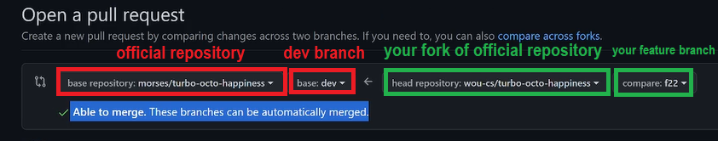

Once everything looks correct, click **Create pull request**.

**Updating from the Official Repository**

Once the Git Master has processed the pull request and merged the changes into the official dev branch, then each developer should update their dev branch:

git checkout dev

git pull upstream dev

And finally, each developer should then also update the dev branch on their remote repo:

git push origin dev

After a sprint is over, each developer should update the main branch as well:

git checkout main

git pull upstream main

git push origin main